Question 1
- A Random variable X has the following discrete distribution as shown below
X | 1 | 2 | 3 | 4 | 5 | 6 | 7 | 8 | 9
P(X=x) | K | 2k | 3k | 4k | 5k | 4k | 3k | 2k | k
Find the;

- value of k
- E(X)
- Var(X)

- Define the following terms;
- Sample space
- Mutually exclusive events
- Independent events

- Events A and B are independent such that P(A)=0.45, P(A)= 0.35. Find the value of;

- P(AnB)
- P(AnB)¹
- P(A)¹
- P(B)¹
- P(AUB)
- P(AUB)¹
- Of the 18,500 traders that participated in the trade show, 8000 deal in cash crops while 6000 deal in food stuffs. 5000 traders deal in items other than cash crops and food stuffs like textile products. Determine the;
- Number of traders dealing in both food stuffs and cash crops.

- Probability that a trader chosen at random from the group deal in only cash crops.

Question two
- A discrete random variable X is defined by
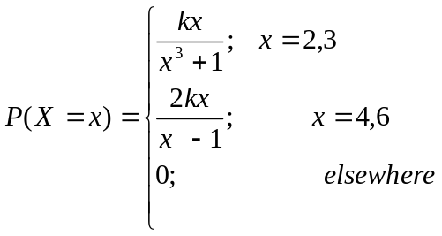
Find the;

- value of
- Expectation of X
- 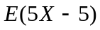
- cumulative distribution function
- Var (X)
- Var (3X+8)
- Mode of X
- Standard deviation of X
- Coefficient of variation

- A continuous random variable X is defined by
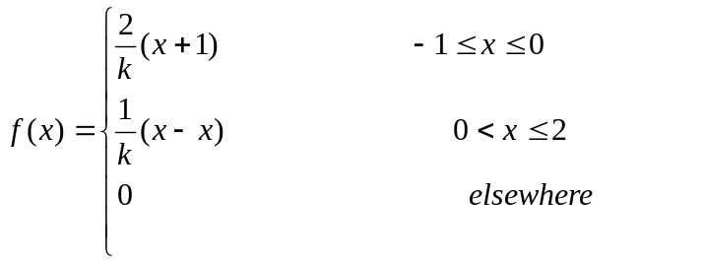
Find the;

- Value of k
- E(X)
- E(4X+12)
- Var(X)
- Mode of X
- Median of X
- Var(3X+2)
- Standard deviation of X

- Find the value of k for which the function 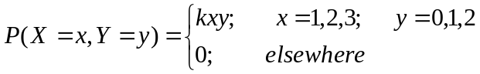 is a joint distribution function of x and y.
- Show that the function 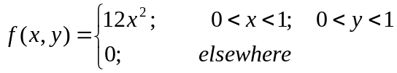 is not a proper pdf of x and y.
- Show that the joint pdf of x and y given by 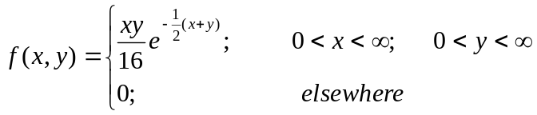has marginal pdf of x and of y given by 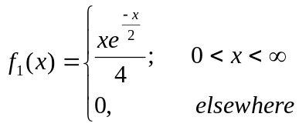and 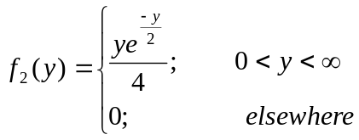respectively.

